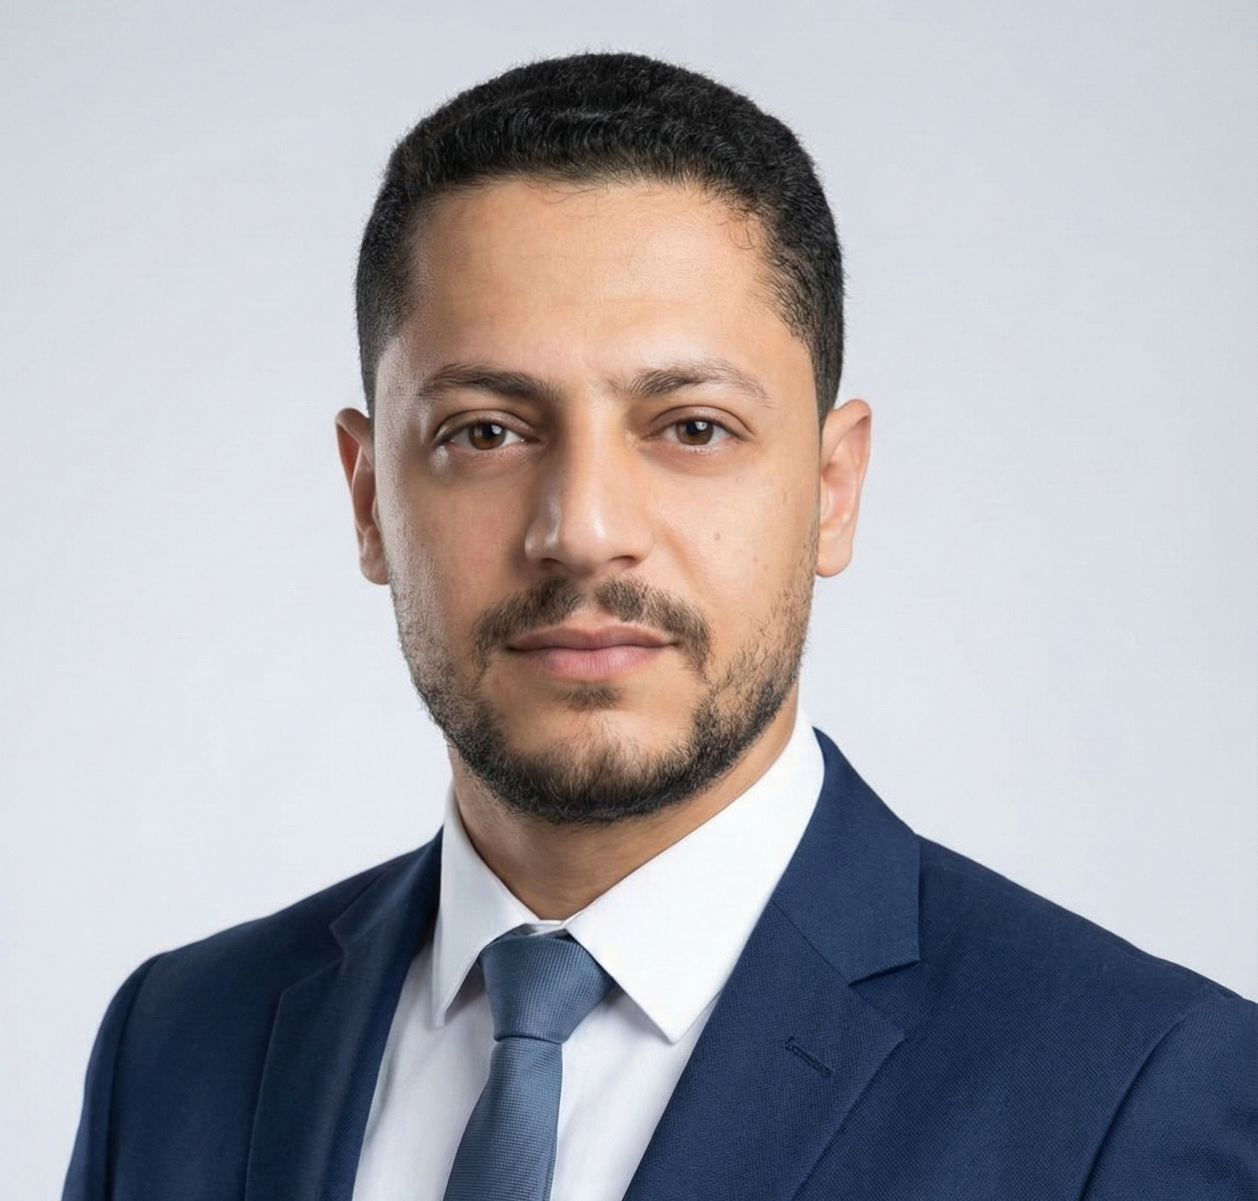 | Ahmed Abdelbaset Badir  Riyadh, Saudi Arabia  Tel: 0502013901| Yaseen.ahmed5382@gmail.com

Objective:
Seeking a position as an Aluminum Fabrication Foreman or Assistant supervisor, where I can apply my technical expertise and leadership skills in manufacturing kitchens, doors, windows, and curtain wall systems. Dedicated to ensuring high-quality production, efficient workflow, and smooth coordination across all project stages.
Education:
- Technical Commercial Institute – Tanta - Egypt
Diploma in Commercial Studies (2010–2012)
- El-Shaheed Hilal Secondary School- Kafr El-Sheikh - Egypt
General Secondary Certificate — 2008
Experience:
ALU System Company — Riyadh, Saudi Arabia 2023 – 2025
- Worked as the Foreman in charge of aluminum curtain wall and mashrabiya fabrication at the STC Smart Site
- Worked as Fabrication Technician on the following projects:
Riyadh Specialized Hospital – Riyadh, Y7 Project, Dr. Soliman Fakih Hospital, Madinah Gate, Kingdom Gate, Novotel Hotel, Al Inma Bank, Red Sea Project (Curtain Wall), Sindalah Island, Dar Al Hijra, Misk Project, Amala Island
Materials & Systems Used:
Unities (Curtain Wall & Aluminum Systems), Alupco, Technal, Gutmann, Alumile, Cladding
Project Supervisor — Al Massa - Al, Riyadh 2022 – 2023
- Supervised aluminum and curtain wall installations.
- Worked on :
  - Taya Center
  - Al Bilad Bank – Al Hamra District
  - Al Bilad Bank – Hafar Al-Batin
  - Al Riyad Bank – Al Rabee District
Aluminum Technician — Ajwad Company, Riyadh 2020 – 2022
- Fabrication and installation of kitchens, windows, and doors.
- Worked on:
  - Riyadh Metro
  - Al Bathaa Curtain Wall Project
  - National Guard (Kitchens & Windows)
Aluminum Technician — Zamzam Company, Kafr El-Sheikh 2017 – 2020
- Fabrication of all aluminum types: kitchens, windows, doors, curtain walls.
- Performed maintenance and execution duties.
Aluminum Technician — Al Nokhba Establishment, Al-Qassim 2015 – 2017
- Worked on various fabrication and installation projects across Qassim.

Aluminum Technician — Zamzam Company, Kafr El-Sheikh 2015 – 2015
- Fabrication of all aluminum types: kitchens, windows, doors, curtain walls.
- Performed maintenance and execution duties.
Aluminum Technician — Quality Company, Sirte, Libya 2012 – 2015
- Manufacturing kitchens, doors, and windows.
Skills
- Strong fabrication and assembly skills
- Aluminum systems (Curtain Wall, Kitchens, Doors, Windows)
- Team Leader & workflow management
- Quality control and project execution
- Measurements, cutting, and installation expertise

